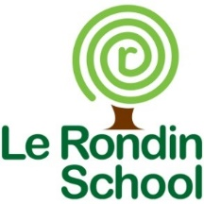 | Le Rondin School  Rue des Landes  Forest  Guernsey GY8 0DP  Tel: +44 (0) 1481 228300  Email: office@lerondin.sch.gg  Website: www.lerondin.sch.gg  Headteacher: Mrs P Sullivan  Email: headteacher@lerondin.sch.gg

Sponsor’s name |  | Amount
 | TOTAL RAISED
Child’s Name:___________________________ Class: ___________

