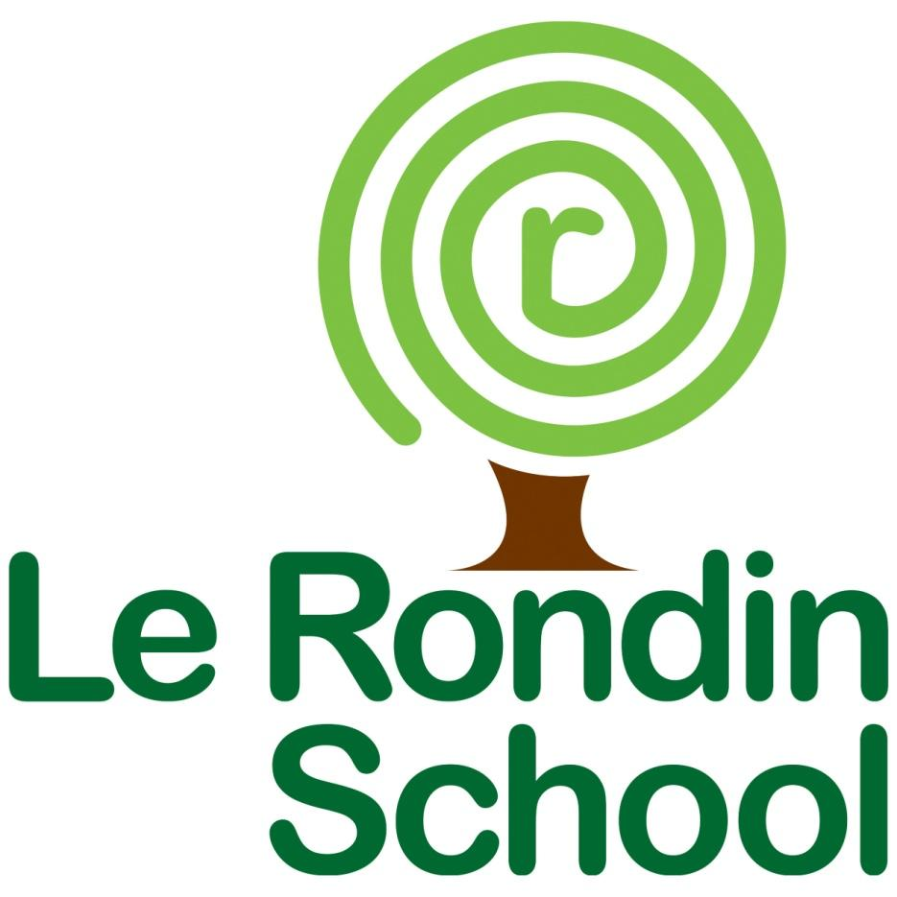
Communication, Language and Literacy
Policy

Caitlin de Garis January 2023 Final
School Aims
Le Rondin School aims to provide a curriculum tuned to the needs of individual pupils with a wide range and varying degrees of special educational needs, in an environment that is purposeful and secure.
We want our pupils to be ‘The Best They Can Be’ and become
Confident Individuals
Successful Learners
Responsible Citizens
Effective Contributors
and to achieve the outcomes set out by the Children’s and Young People’s Plan (CYPP 2016-2022) to
Be safe and nurtured
Be healthy and active
Achieve individual and economic potential
e included and respected

Introduction
This policy document is a statement of the aims, principles and strategies for the teaching and learning of Communication, Language and Literacy (CLL) developed at Le Rondin School.

CLL contributes to the school curriculum by developing pupils’ abilities to communicate, listen, read and write for a wide range of purposes using language to learn and communicate ideas, views and feelings.

It is our view that the pupils in the school should be taught in a safe, secure and stimulating environment enabling them all to achieve their potential in the areas of CLL.

Aims

As a Rights Respecting School we uphold the articles from the United Nations Convention on the Rights of the Child. These articles underpin our CLL policy:
- Article 28 (right to education) Every child has the right to an education. Primary education must be free and different forms of secondary education must be available to every child. Discipline in schools must respect children’s dignity and their rights.
- Article 29 (goals of education) Education must develop every child’s personality, talents and abilities to the full. It must encourage the child’s respect for human rights, as well as respect for their parents, their own and other cultures, and the environment.
- Article 23 (children with a disability) A child with a disability has the right to live a full and decent life with dignity and, as far as possible, independence and to play an active part in the community. Governments must do all they can to support disabled children and their families)
- Article 3 (best interests of the child) The best interests of the child must be a top priority in all things that affect children.
- Article 17 (access to information from mass media) Every child has the right to reliable information from the media. This should be information that children can understand. Governments must help protect children from materials that could harm them.

The aims of teaching CLL are:
- To develop pupils’ confidence in themselves as skilled communicators, to have a voice, make relevant contributions and learn how to listen attentively to others.
- To enable pupils to adapt their communication to a widening range of circumstances and demands.
- To develop pupils’ interest and pleasure in reading, so that pupils can recognise and interpret photographs / pictures / signs and symbols and express preferences about their reading.
- To enable pupils to value reading materials and be involved in choosing from a selection of media. For example books, both fiction and non-fiction, computer-based programs and the internet.
- To enable pupils to read with as much fluency, accuracy and understanding as possible.
- For pupils to enjoy writing and to see the value of it in real life situations.
- To provide stimulating opportunities for pupils to be creative writers of text and to express themselves, in writing, with confidence.
- To develop pupils’ understanding that writing is essential to thinking and learning across all curriculum areas.
- To enable pupils to use the planning, drafting and editing processes to improve their written work and sustain their writing of fiction, non-fiction and poetry.
- For pupils to be able to use ICT as an effective means of communication and an effective tool for learning.
- To set suitable learning challenges in response to pupils’ diverse learning needs and overcome potential barriers to learning and assessment for individuals and groups of pupils.

Intent

The Communication, Language and Literacy curriculum has been developed in line with the school values of inclusive, aspirational and child centred education. We believe that our curriculum should develop children’s love of reading, writing and speaking and listening skills.

We recognise the importance of children being able to write legibly, fluently and at a reasonable speed. With these skills, children have a much greater chance of being able to reach and demonstrate their potential throughout their school careers and in their lives beyond school.

By creating and responding to all kinds of texts, including those which combine words, images and sounds, our curriculum is designed for students to access a world of knowledge, experiences and imagination. It intends to create a life long enthusiasm and enjoyment of reading.

As stated in the Guernsey Curriculum, students “... developing use of language underpins learners’ achievement across the curriculum and lays the foundations for active involvement in cultural life, society, work and lifelong learning”. This is a fundamental teaching point for our students, with a high importance placed on specific vocabulary work built into the curriculum throughout the school.

We aim to ensure students become increasingly fluent in their communication by expressing opinions and emotions through Literacy. This helps learners to develop their imagination, empathise with others and develop problem solving and critical thinking skills.

Communication, Language and Literacy at Le Rondin provides students with a range of possibilities, enabling them to engage with different cultures and societies and further developing their understanding of how to communicate with others throughout their lives.

Implementation
These aims are embedded within Literacy and cross-curricular learning. We have a highly specific, well organised curriculum that provides our students with purposeful opportunities for reading, writing and discussion. We use a wide range of high quality texts throughout the school to support and motivate learners. The program of study has been designed to compliment and provide cross-curricular links where appropriate.

Reading
At Le Rondin, the greatest possible emphasis is placed on reading. We believe that the ability to read with understanding and enjoyment is of prime importance.

In EYFS individual Reading is part of each Literacy session. Pupils have a choice of appropriate, decodable texts and are supported with the processes of reading. Adults support pupils with texts outside of their reading ability by engaging children in regular story time.

Throughout key stages 1 and 2, we use Read Write Inc., an inclusive, well-researched synthetic phonics program that teaches students decoding, encoding, fluency and comprehension skills. Each teacher is trained in Read Write Inc. delivery and accesses online and physical support materials. Within each class there are appropriately levelled speed sounds charts and picture friezes to support students in every lesson.

Students who have completed their phonics learning access spelling sessions and guided reading groups that are tailored to their needs. Some examples of texts that students use are: The Twits (Roald Dahl), Hodgeheg (Dick King Smith), Bill’s New Frock (Anne Fine). Guided reading sessions occur at the same time as our Phonics provision.

In line with our RWI program, each student is regularly assessed to ensure they are accessing the appropriate level for Phonics and their individual reading books. All pupils have access to phonetically decodable books that they take home to read to adults.

Students also have access to a range of texts through our school library and class libraries. They are encouraged to share these stories and books with adults outside of school. Teachers and LSAs within school read a range of books to students throughout the year purely focussed on reading for pleasure.

We have a reading spine that is integrated into daily story time across the school. This reading spine includes a range of texts that explore social, moral, cultural and historical aspects of society. Each year has access to texts, including archaic texts, that have been chosen for their cognitive and social development.

Building on the strong foundations of our EYFS provision, reading is also deeply embedded within our writing curriculum for years 1-6 and our Language and Communication curriculum, with carefully selected books being a starting point for each Literacy lesson.

Writing

In EYFS and Language and Communication classes, students develop skills in mark making and graphemic understanding through continuous provision, sensory exploration and gross motor skills development. They utilise Write Dance as part of their writing curriculum. This is a music and dance approach and a method that provides movement opportunities so children can develop the physical skills needed to develop mark making and writing skills. The movement is driven by the music and the underlying principle is enjoyment to build confidence. This combination of rhythmic and then melodic pieces of music are chosen so the children can follow and learn specific movements to develop their physical skills including, balance, coordination, flexibility and stamina.

Following on from our EYFS provision, we use the Literary Curriculum as a starting point for our learning. The Literary Curriculum is a complete, thematic approach to the teaching of primary English that places children’s literature at its core. Each unit has been chosen to compliment themes, subjects or topics that students access throughout the year. Students access 6 chosen texts throughout the year and these are on a two year rolling program. Children purposefully apply their writing skills within a wide variety of written outcomes.

We teach children to spell using a range of strategies. We pay attention to sounds, pattern and shape, as highlighted within the Read Write Inc. scheme, as well as encouraging the child to develop their own observation and memory. Children have to be given the opportunity to explore and “have a go” with spelling. They must also become accurate, so that spelling is an automatic activity. Children are taught to use their phonic knowledge to write words in ways which match their spoken sounds, as well as being able to write some common words with irregular spellings. This is then extended into using alternative graphemes for accurate spelling.

We believe it is vital that children have a solid understanding of vocabulary and understand that this needs to be explicitly taught. This is embedded across the curriculum with a focus on topic specific vocabulary delivered at the start of each topic.

Communication
Across the school children are given the opportunity to develop their communication skills through performance for their peers, the school, parents and the wider community.

In our Language and Communication classes, students access Literacy learning through the “Tell Me Program”. This is a book based learning experience where students use sensory exploration and repetition to develop their communication and understanding. Each child in the Language and Communication setting has an individual communication target. Students will achieve these targets through a range of communication aids, adult led learning and individual exploration.

Students with specific communication needs have designated time working with the Speech and Language team. They support staff in the use of AAC devices, communication boards and PECS. Staff are trained by SaLT leaders on any specific interventions needed for students.

Impact

As a result of our curriculum, students develop their knowledge and skills within Literacy. They will make marked progress in reading, writing and communication.

We measure the progress students make at Le Rondin through:

- Formal assessment data entry (SIMS)
- Half termly phonics assessments
- Yearly Salford reading assessments
- Creative writing books (3 pieces of work per year)
- Informal class observations
- Informal collegiate moderation
- Clear adaptations made to content for pupils and progression in books
- Pupil progress meetings

The vast majority of students will be leaving Le Rondin with a secure understanding of phonics and will be able to access higher level texts when they reach secondary school.

Students will be engaged in their learning throughout the school, showing a love of learning and reading for pleasure. They will be able to apply their knowledge and understanding of Literacy to other areas of the curriculum.

Organisation and Methodology
Half termly coverage is divided into poetry, narrative and non-narrative.
CLL is taught daily as a discrete subject throughout the school.
Sessions are organised as:
- 30 minute daily synthetic phonic system (Read Write Inc)
- Poetry / narrative / non-narrative focus (The Literary Curriculum, Tell Me Programme, CLPE, Talk 4 Writing)
- Learners experience at least three 1:1 reading sessions per week

Roles and Responsibilities
It is the role of the CLL Leader to:

- Implement and monitor the CLL Policy
- Attend meetings/training and keep up-to-date with new initiatives and ideas, disseminating these with staff where appropriate. Training is primarily delivered by The Somerset Literacy Network (SLN) and Schools Library Service.
- Monitor planning, marking and feedback and liaise with teachers and pupils where appropriate
- Coordinate the purchase of resources and be responsible for their organisation.
- Ensure that the CLL resources are of a high quality, will appeal to the full range of children’s needs, interests and abilities, and are sufficient in quality and quantity to fulfil the needs of the new Guernsey Curriculum.
- Liaise with Speech and Language Therapists
- Liaise with the Schools Library Service (SLS) to develop Le Rondin’s library facility and resources.
- Organise and run the school library.
- Oversee parental liaison in the area of CLL.
- Coordinate the purchase and delivery of resources and training in the school signing system ‘Signalong’.
- To monitor overall progress and attainment in CLL across the school.
- To monitor the learning and teaching in CLL across the school.
- Write a yearly Action Plan, identifying areas for improvement linked to the School Improvement Plan, Ofsted framework and Children and Young Person’s Plan 2016-2022, where appropriate.

Monitoring
Monitoring is carried out by the CLL coordinator through:
- Learning walks and observations
- Monitoring of planning, marking and feedback
- Termly moderation and external moderation through the SLN
- RWInc testing and Salford Reading testing
- Tracking of writing through termly set writing tasks.
- Analysing progress and attainment data.

Evaluation
Monitoring and evaluation of the standards of the children’s learning and quality of the teaching in CLL is the responsibility of the CLL lead and SL in partnership with the Head Teacher.

Authorship Caitlin de Garis
Date of policy January 2023

Appendix 1: Reading and Writing

Reading is developed through:
- Using RWInc synthetics phonics scheme where most pupils are taught in groups according to their progression in the scheme.
- Pupils having access to a wide range of literature and non-fiction texts in classrooms, in a central resource area and the school library.
- The use of ICT based reference materials e.g. Interactive library, Seesaw, DVDs, audio books.
- Providing a language rich environment and interactive displays in order to stimulate pupils’ reading.
- Where appropriate sessions of independent reading where pupils have the opportunity to practice reading skills acquired in RWInc sessions to enable them to, enjoy and share texts with other pupils and adults.
- The involvement of parents thereby ensuring a home/school commitment to the encouragement and value of reading.
- Reading volunteers supporting 1:1 reading, targeting students who do not regularly read at home
- Reading curriculum is supplemented through Literacy lessons - Range of key texts have been chosen to expose children to books that they may not access in their daily lives.
- Pupils being able to borrow books from the school library which is open daily.
- The involvement of the school in Island Library Service initiatives such as ‘Book Week’, ‘World Book Day’ and visiting authors.

Writing is developed through:
- Developing pre writing skills through such activities as Write Dance and other gross and fine motor activities.
- Using RWInc scheme where most pupils are taught writing alongside reading in groups according to their progression in the scheme.
- The use of I.C.T, to support and aid writing.
- The provision of a wide range of purposes for writing, including communication with others, exploring experience and organising and explaining information.
- The provision of opportunities to practice a wide range of writing forms especially linked to Topics.
- Providing opportunities to write appropriately for a range of audiences.
- Teaching pupils the main rules and conventions of written English.

Work in Communication and Listening, Reading and Writing is integrated throughout English and Literacy and through all other curriculum areas and the links between these are made explicit to the pupils. English and the skills of Literacy are seen as the media through which pupils learn and they are drawn on extensively in other subject areas.

Planning.
Planning for Communication Language and Literacy is done at three levels:
1. Whole school planning, (Long term)
2. Half termly overviews (Medium term)
3. Weekly planning, (Short term)
4. Individual RWInc group planning and teacher’s class planning (Short term )

Planning is completed using the guidance of RWInc scheme, Guernsey Curriculum, ongoing dynamic classroom assessment,termly assessment data and progress, set writing tasks and topic based learning opportunities.

Assessment and Recording.
- Pupils’ development in reading and writing is constantly monitored and assessed in order to inform future planning, teaching and reporting.
- A variety of methods are used in order to provide a broad and balanced picture of pupils’ skills.
- A variety of record keeping methods are also used to suit the purposes of the assessment.
- All staff keep class assessment records books or files, to take advantage of incidental and informal assessment opportunities.
- All formal assessments are passed to the receiving teacher at the end of the academic year.

Assessment of Reading

- Pupils’ reading behaviour is observed and noted by the RWInc teacher and class teacher comments about home reading behaviour are also noted.
- Pupils’ progress in reading is assessed through RWInc testing and Salford Reading Test
- Whole school assessment of reading also occurs through termly leveling as outlined by the Guernsey Grids and P-Scale assessment guidance

Assessment of Writing

- Pupils’ writing is assessed regularly against the appropriate learning objectives as detailed in the Guernsey Grids
- Pupils’ writing can also be assessed against appropriate learning objectives as outlined in the RWInc scheme.
- Pieces of annotated work are kept to mark pupils’ progress in writing and this again forms part of the assessment portfolio and informs the writing of reports to parents.
- Whole school assessment of reading also occurs through the Guernsey Grids and P-Scale assessment guidance.
- Termly independent writing tasks also aid teachers when establishing levels.

